**JUNIT**

**MANDATORY**

**1. JUnit_Basic Testing Exercises**

**Exercise 1: Setting Up Junit**

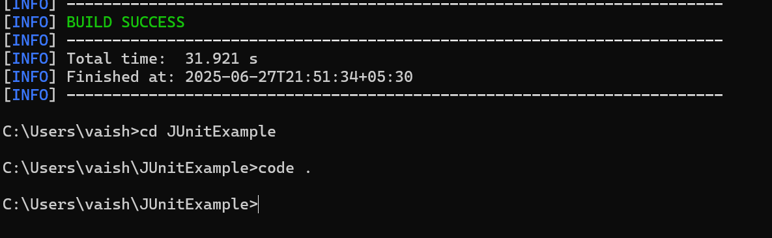

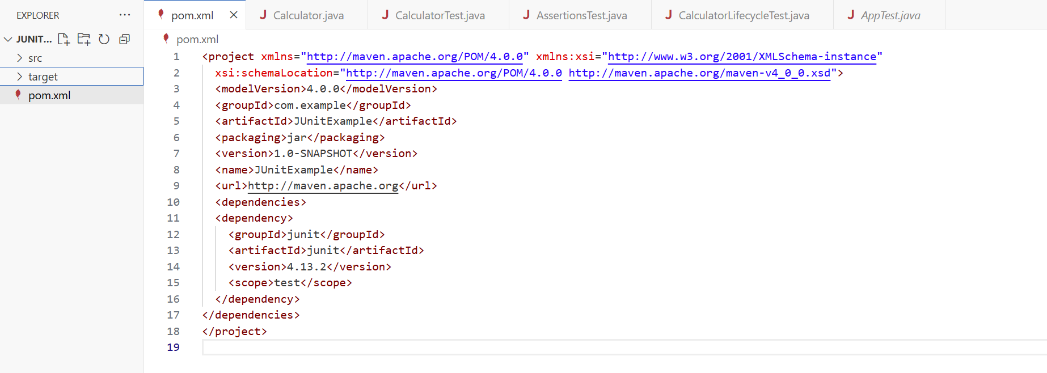

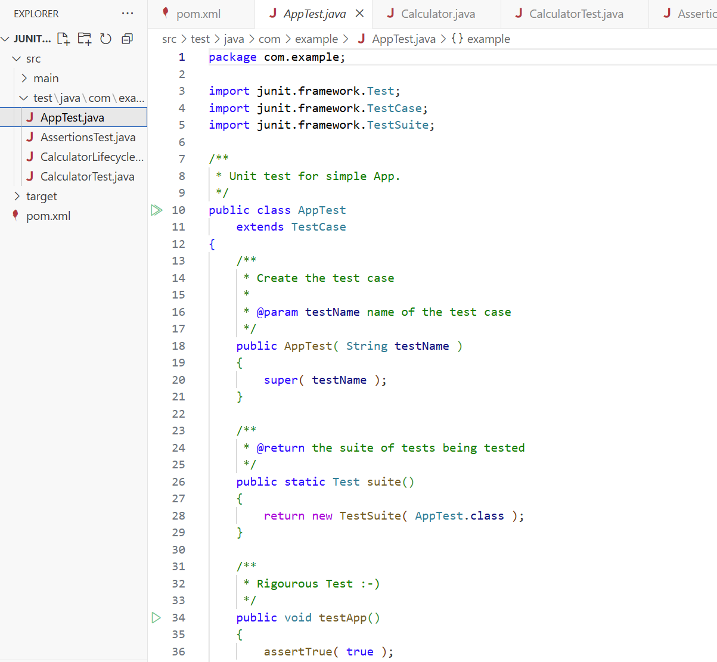

**Exercise 3: Assertions in Junit**

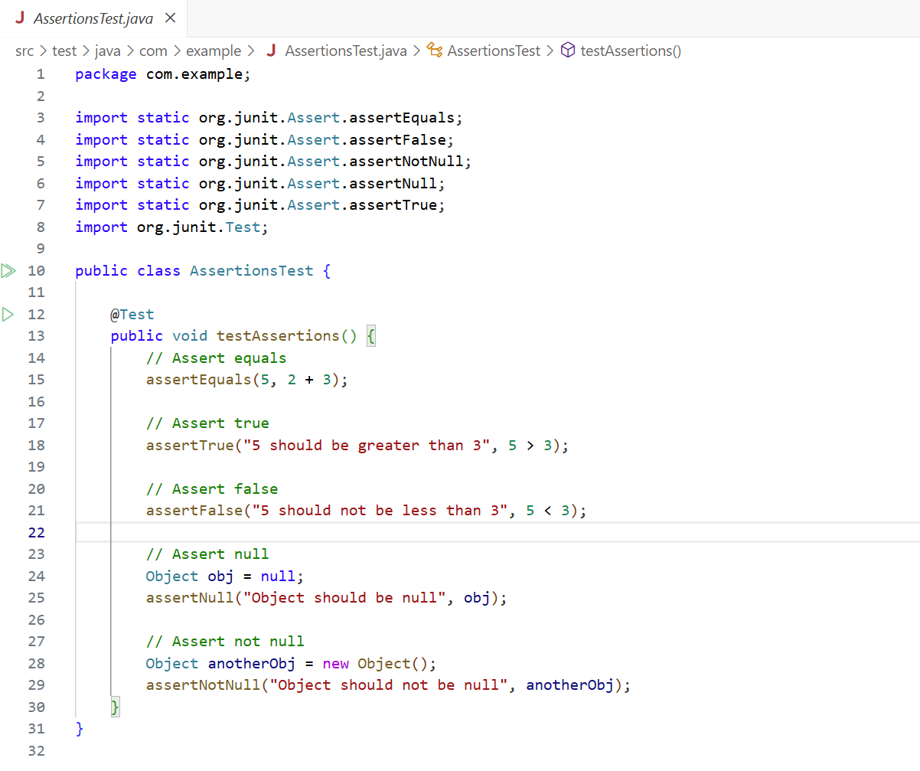

**OUTPUT:**

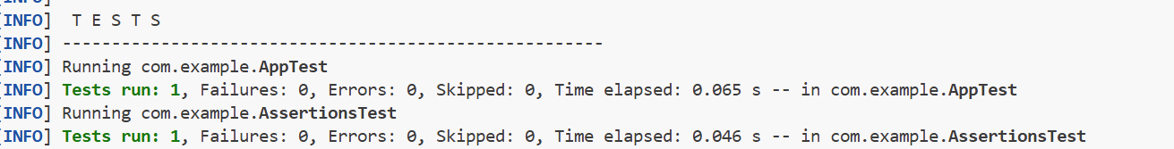

**Exercise 4: Arrange-Act-Assert (AAA) Pattern, Test Fixtures, Setup and Teardown Methods in Junit**

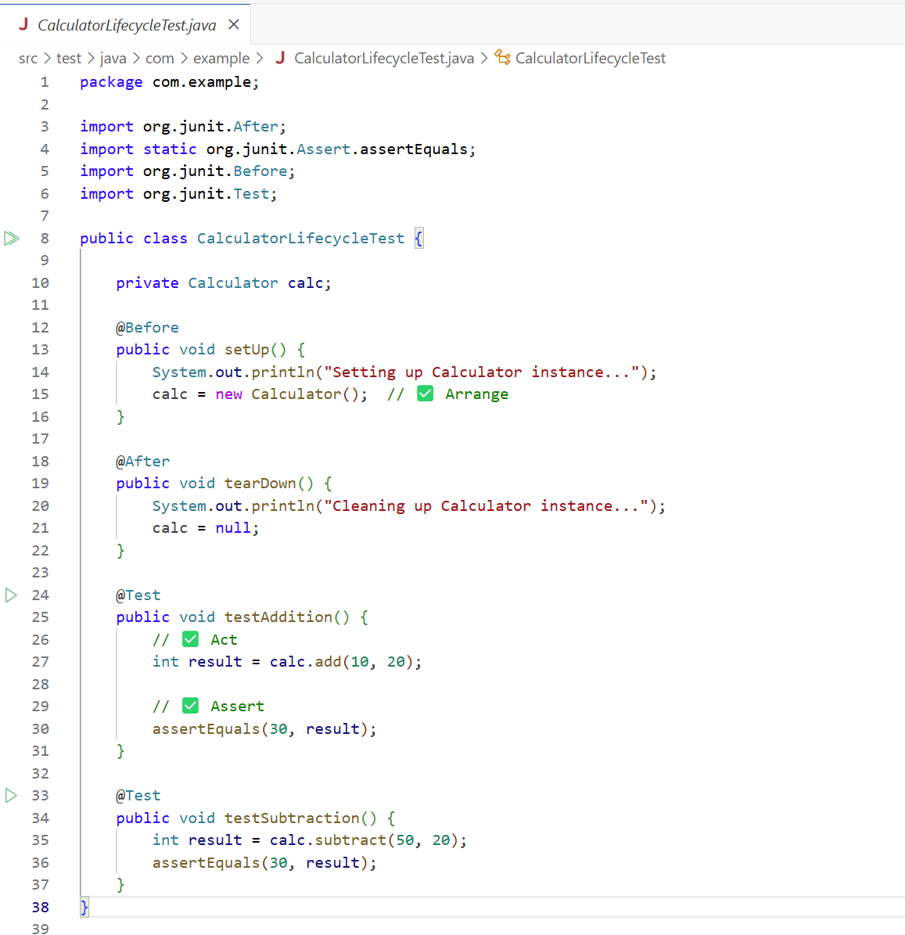

**OUTPUT:**

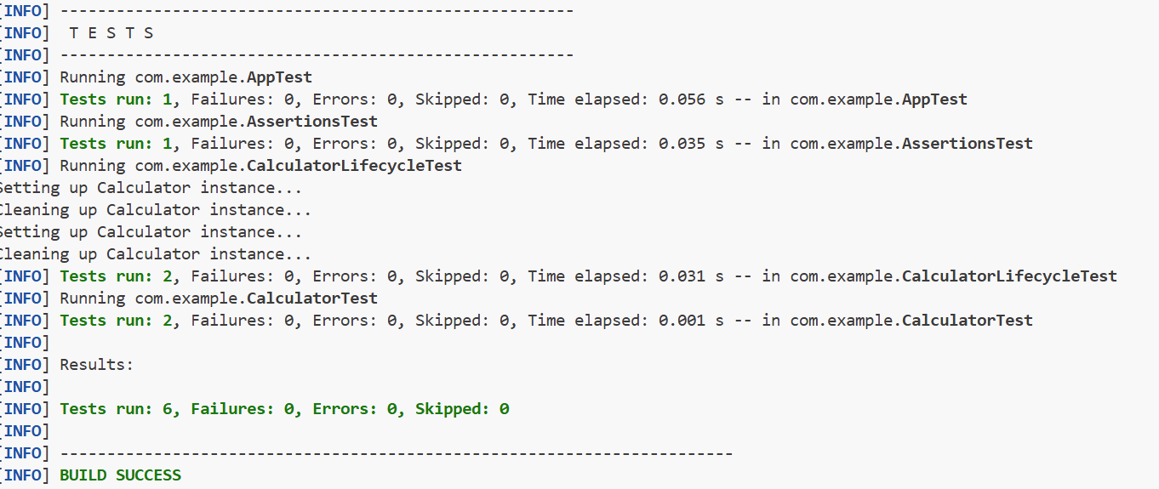

**3. Mockito exercises**

**Exercise 1: Mocking and Stubbing**

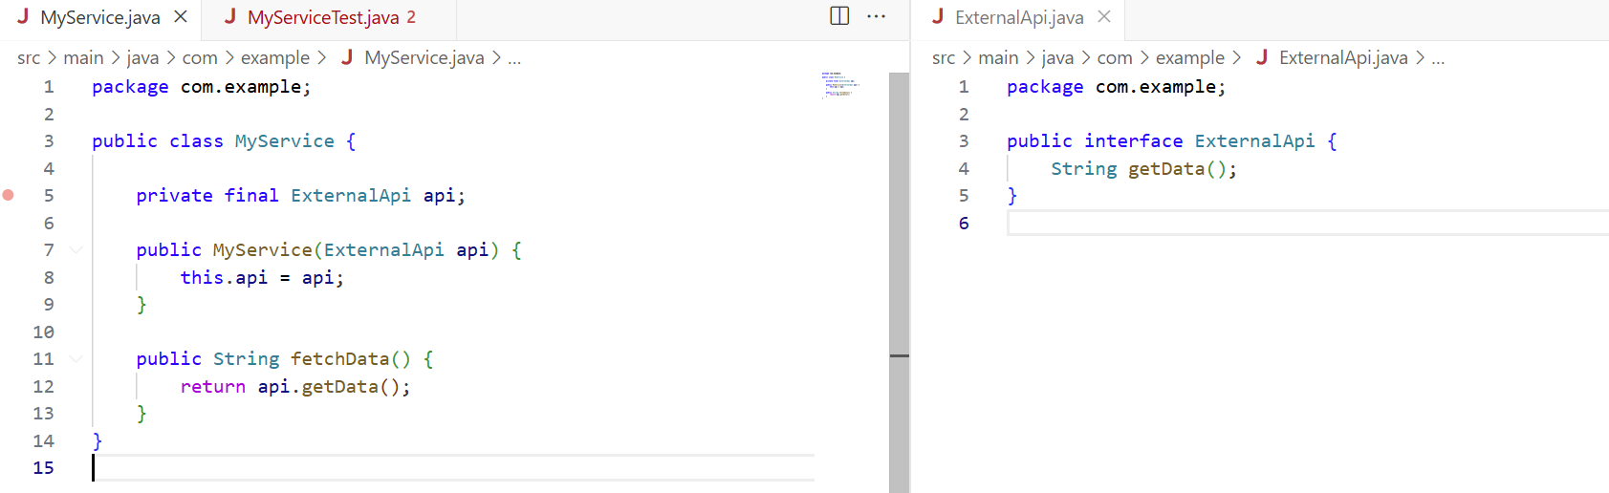

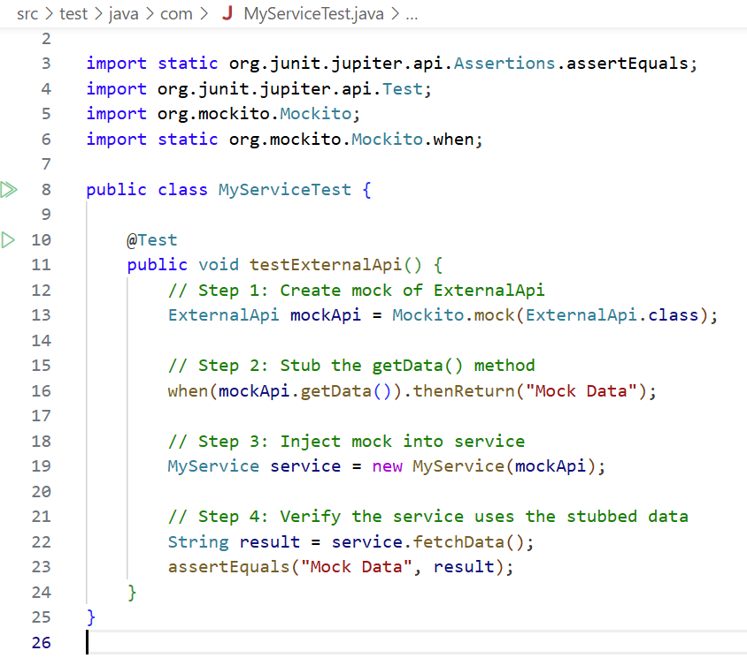

**OUTPUT:**

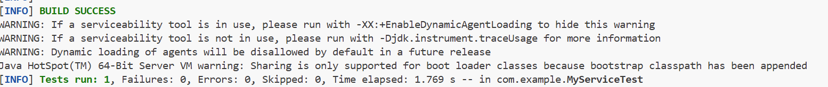

**Exercise 2: Verifying Interactions**

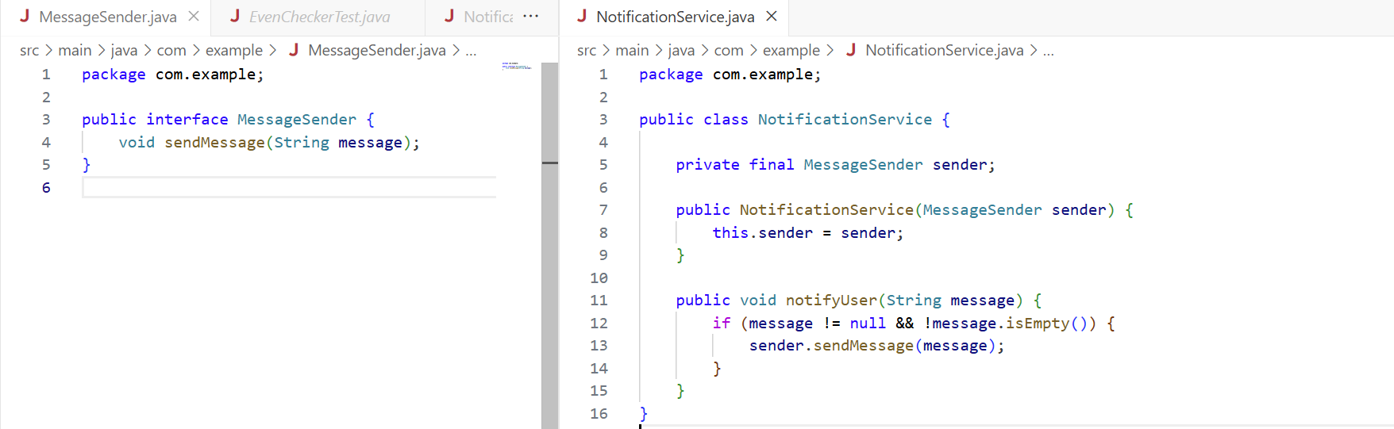

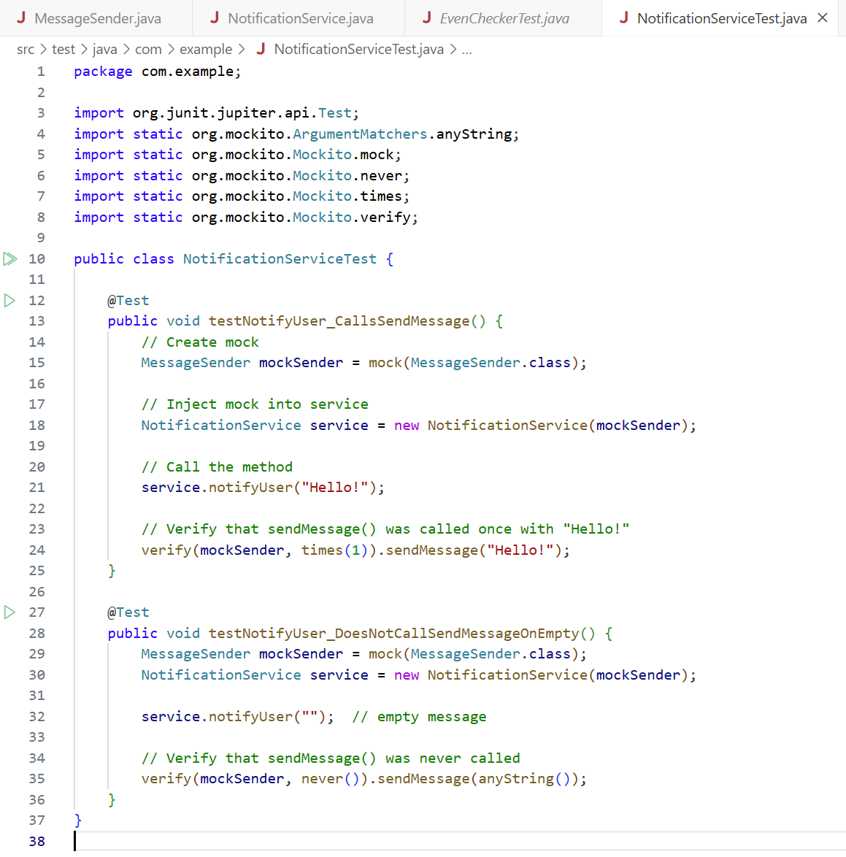

**OUTPUT:**

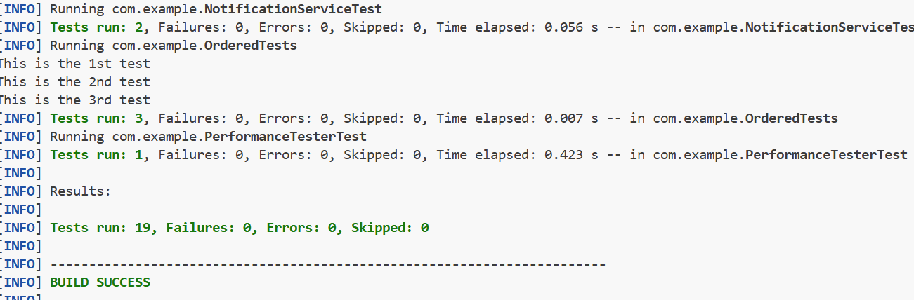

**ADDITIONAL**

**1. JUnit_Basic Testing Exercises**

**Exercise 2: Writing Basic JUnit Tests**

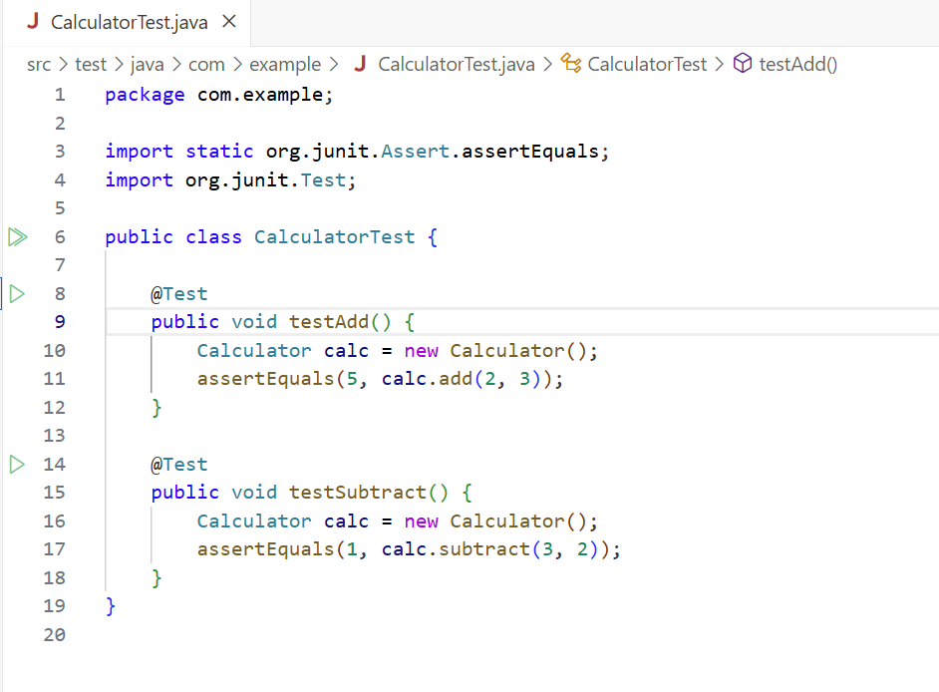

**OUTPUT:**

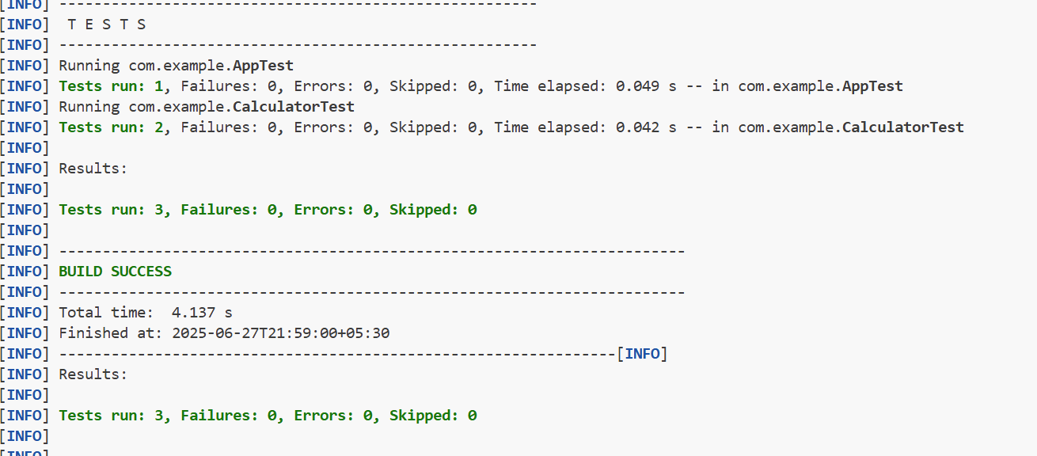

**2. JUnit_Advanced Testing exercices**

**Exercise 1: Parameterized Tests**

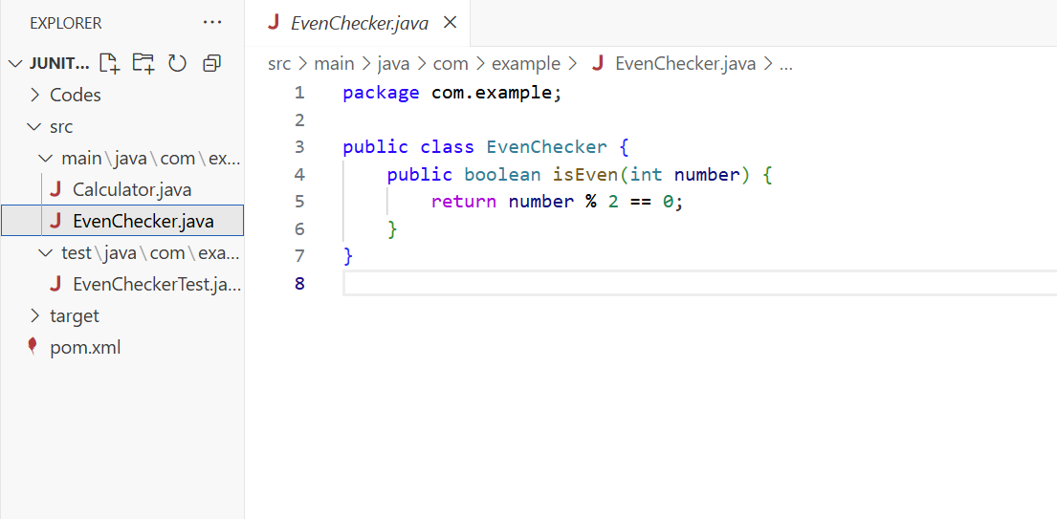

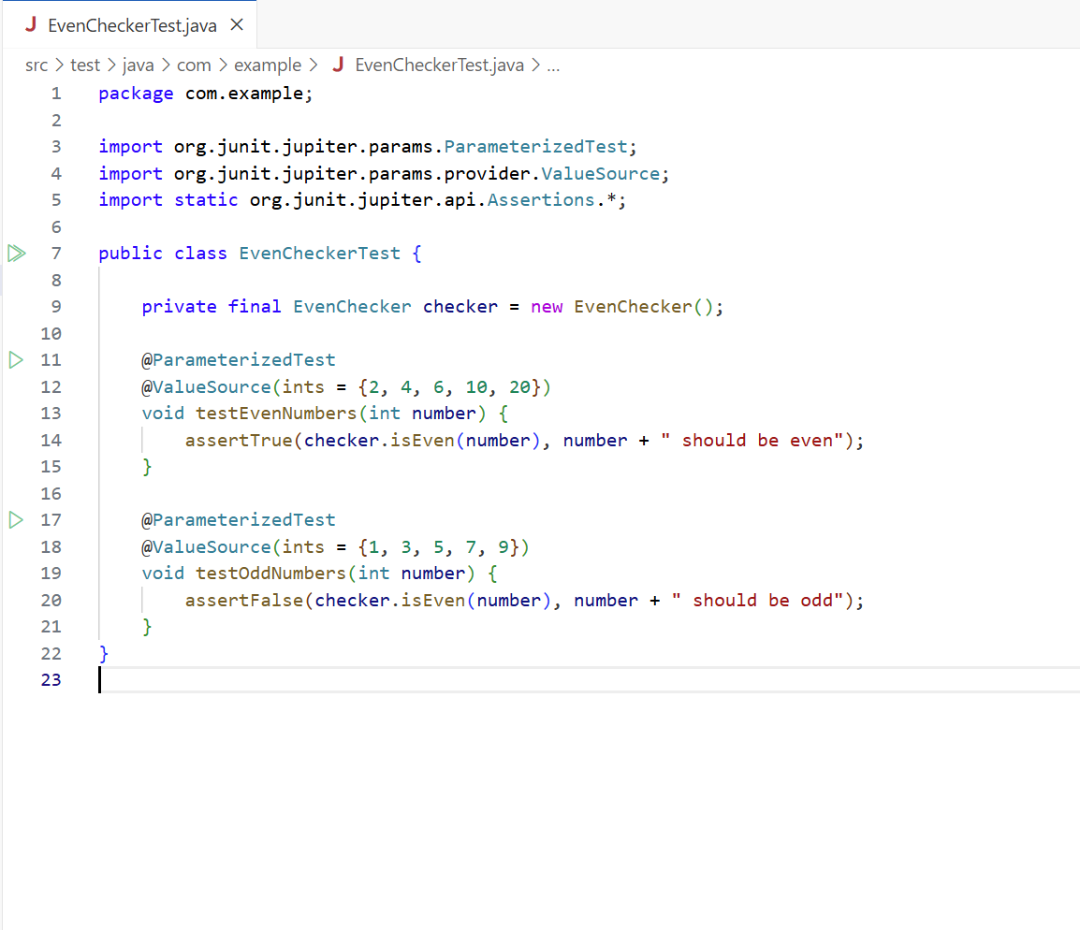

**OUTPUT:**

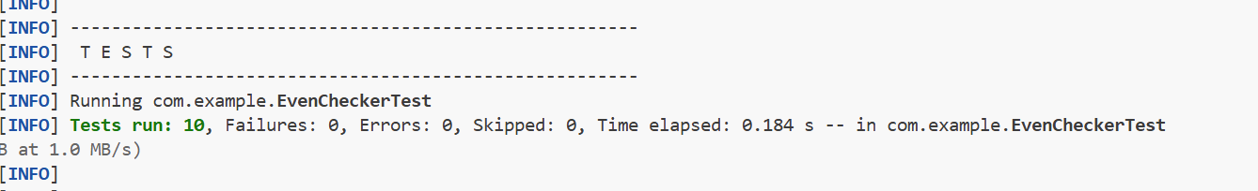

**Exercise 2: Test Suites and Categories**

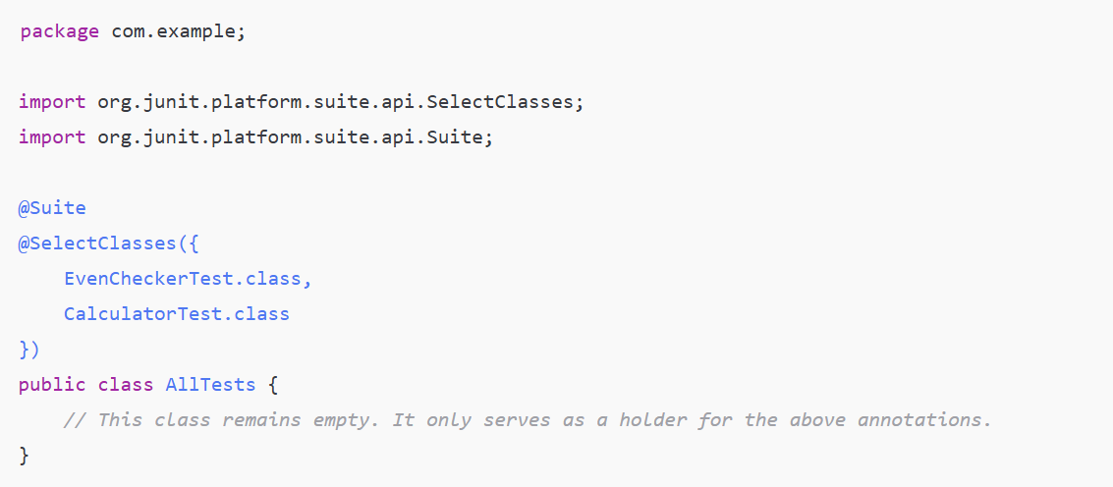

**Exercise 3: Test Execution Order**

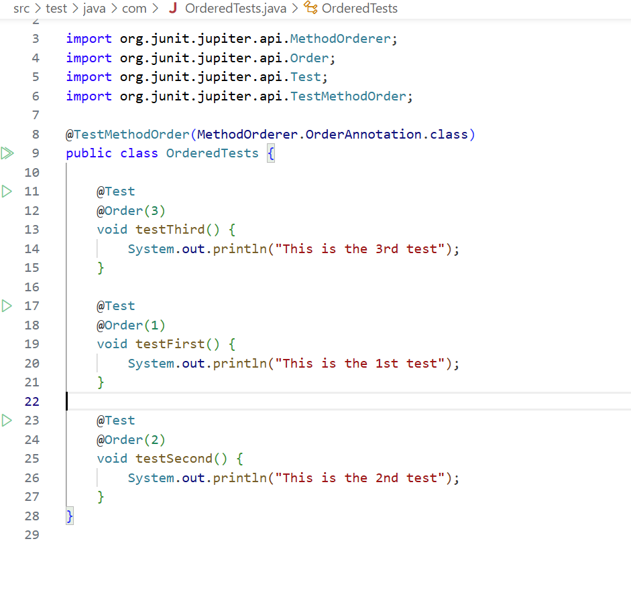

**OUTPUT:**

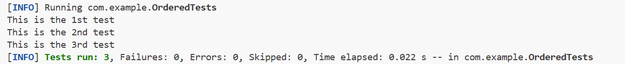

**Exercise 4: Exception Testing**

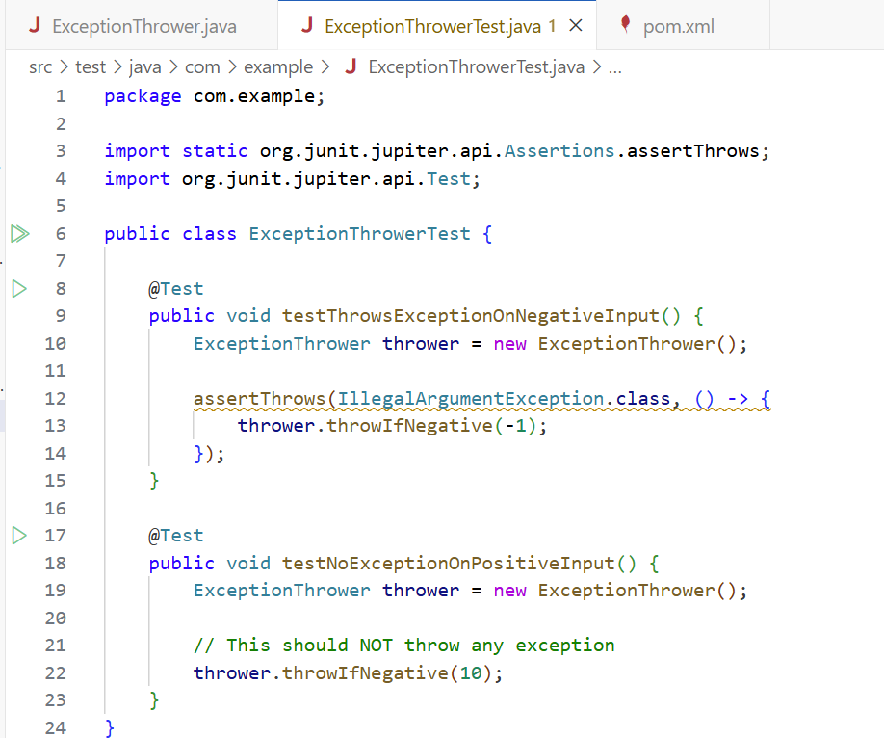

**OUTPUT:**



**Exercise 5: Timeout and Performance Testing**

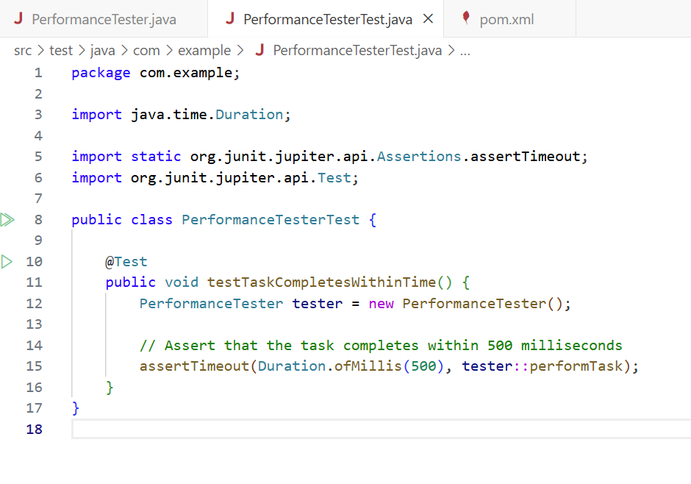

**OUTPUT:**

